EXP-2,3
2. Sketch a Simple Prototype of a Bus Ticket Booking System using Figma Tool
Step 1: Select Android medium frame and add texts and placeholders using shapes
Step 2: Again select the frames and add the require this
Step 3: Select the design and connect the frames click on play button for prototype
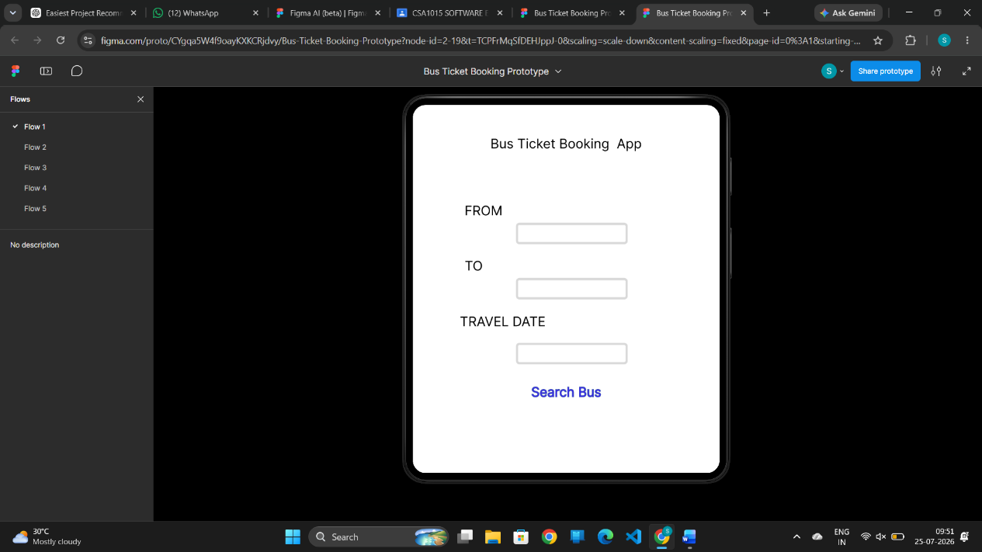
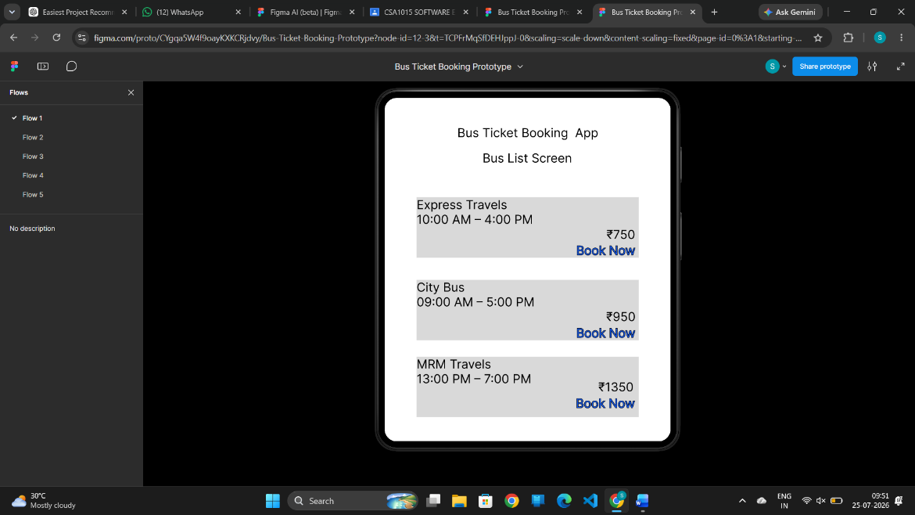
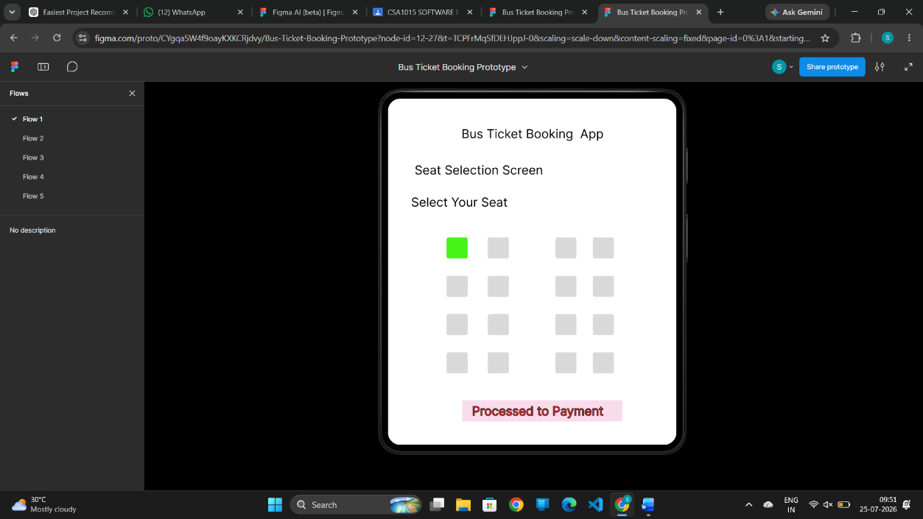
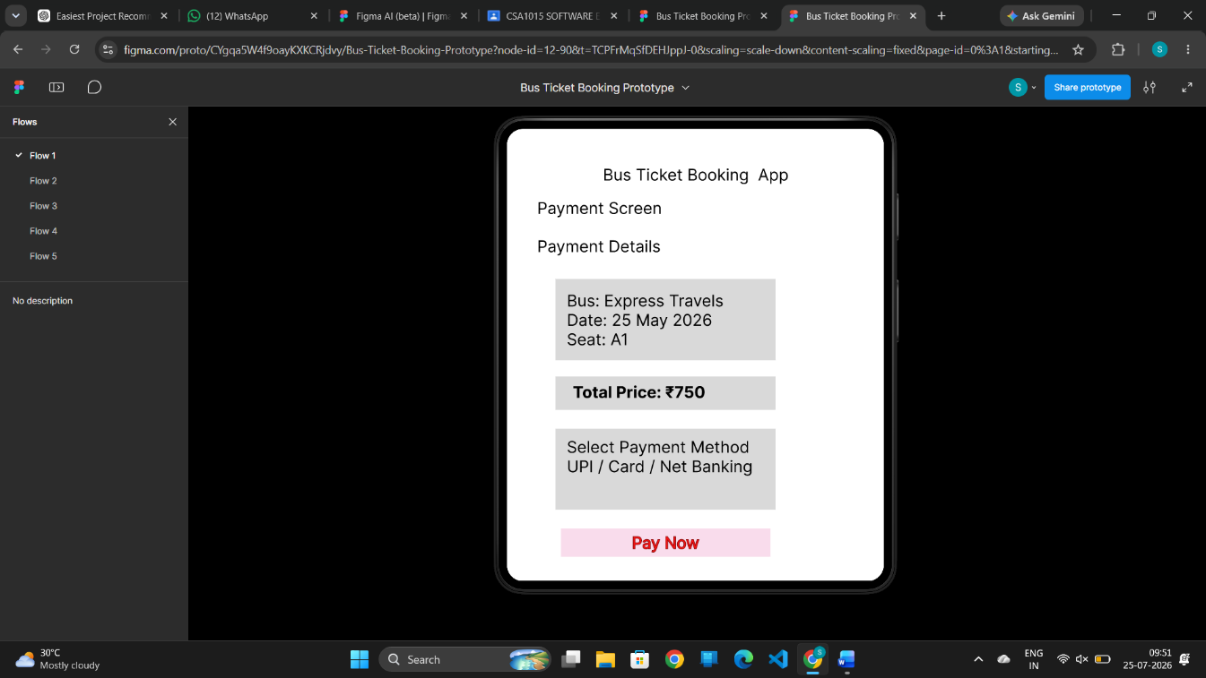
3. The stakeholders have conflicting views on the user interface design for an E-Commerce mobile app. Create a prototype using Figma tool to discuss with the stakeholders to get their feedback and approval.
Step 1: Select Iphone medium frame and add texts and placeholders using shapes
Step 2: Again select the frames and add the require this
Step 3: Select the design and connect the frames click on play button for prototype
